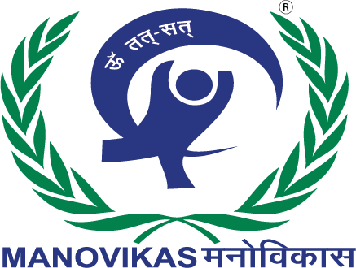
MANOVIKAS CHARITABLE SOCIETY · MANOVIKAS INSTITUTE OF HIGHER EDUCATION
Event Report
World Mental Health Day 2026
Lived Experiences Heard: Real Voices, Real Change
सच्ची आवाज़ें, सच्चा बदलाव
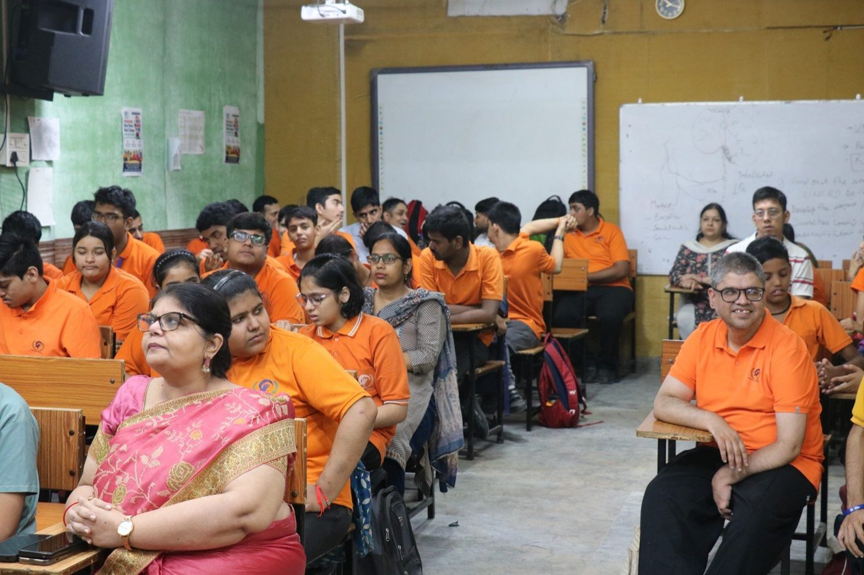
Friday, 9 October 2026 · 10:00 am – 12:30 pm
Manovikas Campus, 60-A Radhey Puri Extension 1, Delhi 110051
Record: Manovikas MIS · Events #5 · Public indicator MV_EVT_01

1. Event at a glance
Event | World Mental Health Day 2026: a lived-experience listening session
Theme | Lived Experiences Heard: Real Voices, Real Change (सच्ची आवाज़ें, सच्चा बदलाव)
Date and time | Friday, 9 October 2026, 10:00 am – 12:30 pm
Venue | Manovikas Campus, 60-A Radhey Puri Extension 1, Swami Dayanand Marg, Delhi 110051
Organised by | Manovikas Charitable Society and Manovikas Institute of Higher Education (MIHE)
Type and format | Awareness day; in person; participatory sharing session, display wall and poster gallery
Participants (approx.) | About 160 in total  - Students with intellectual and developmental disabilities (IDD): 100  - Parents and family members: 10  - D.Ed. Special Education (IDD) trainees: 50
Special guest | Mrs. Anita Dalal
Access and inclusion | Sharing in Hindi and English; each person spoke in their own way and at their own pace; visual displays (My Voice Wall) for those who prefer not to speak
Linked goals | UN SDG 3 (Good health and well-being), SDG 4 (Quality education), SDG 10 (Reduced inequalities)

2. About the day
World Mental Health Day is observed every year on 10 October. Manovikas marked it a day early, on Friday 9 October 2026, with a simple idea: this year we would not speak about people with intellectual and developmental disabilities; we would listen to them. Students, parents, and teachers-in-training were invited to share their routines, growth, hopes, and the support that helps them feel well.

Objectives
- Give students with IDD and their families a safe, respectful space to share their own experiences.
- Help trainee special educators practise listening, a core skill for inclusive classrooms.
- Raise awareness that mental well-being depends on family understanding, social support and opportunities to learn and work.

3. Programme
Segment | What happened
Opening | Introduction of the theme, Real Voices, Real Change, with a short prayer for well-being shown on screen.
Student Voices | Students came forward one by one to share their daily routines, independence, studies, sport, hobbies, and job hopes.
Parent Circle | Parents shared their experience of raising their children, giving time, and finding support.
My Voice Wall | A display of feelings, drawings and messages titled "Every Voice Matters, Every Mind Matters".
Poster gallery | Mental health awareness posters made by D.Ed. Special Education (IDD) trainees.
Guest address | Mrs Anita Dalal shared her experience, met the students and appreciated the work of teachers and mentors.

4. What we heard
The statements below are summarised from the session notes. They are grouped by theme.

Daily routines, personal growth and independence
- Shivanshu is happy to stay with his parents and keep a daily routine. He spoke warmly of Kandpal Bhaiya and of listening to his parents.
- Chetna described becoming independent: she does her own hair, looks after her clothes and manages her personal tasks. She thanked her teachers for their support.
- Kaka said he started from zero and has learned a lot. He manages his own tasks, plays football, enjoys his favourite singer and hopes to become an Army officer to serve others.
- Deepika is independent and handles household work.
- Puneet Ji said time passes well when he is with the group, rather than at home, and that he helps his mother.

Aspirations, skills and hobbies
- Ujjwal is in the final year of his degree, enjoys social media, and aims for a government job. He said his teachers helped him overcome challenges.
- Nikhil wants to get a job ("job karna chahta hoon").
- Gagandeep is pursuing a beautician course.
- Krishna Rajak loves playing outside, studying, cycling, and ice cream, and he spoke about his best friend, Kaka, and about sometimes feeling shy.
- Raghav shared his journey as an athlete.
- Anu Verma and Vani enjoy watching TV, travelling and spending time with "Dada".
- Anant Bansal sang a song and spoke about his love of music.
- Abhishek enjoys food and dancing, shared his trip to Rajasthan and spoke of his trust in Kallu Sir.

Personal journeys and overcoming challenges
- Sikkaji traced his journey from 27 July 2013. He loves chess and cricket, is content with his work at the post office and considers everyone a friend.
"Koshish nahi chhodi." (I never stopped trying.) — Sikkaji
- Kandpal spoke about the food he enjoys, his love of dance, and getting his work done.

Family and community support
- Viraj's mother spoke about raising her child, the importance of giving time, and overcoming difficulties in her own way.
- Afsa raised concerns about community involvement and the need for social boundaries and social support.
- Deepika recalled not being accepted at first by regular or special schools, and finding support by sharing with her teachers.
- Sambhav gave the message that stayed with everyone:
"Parivar ko bhi bachchon ko samajhna chahiye." (Families must understand their children too.) — Sambhav
Special guest. Mrs. Anita Dalal shared her experience and said Manovikas is doing remarkable work. She appreciated the dedication of the teachers and mentors, met the students and blessed them.

5. Outcomes and learning
- Voice and agency. Students with IDD spoke for themselves in front of about 160 people about their routines, skills and goals, including degrees, government jobs, the Army, sport and paid work.
- Independence as well-being. Personal care, household work and daily routines came up again and again as sources of pride and confidence.
- Family understanding. Students and parents both named family understanding and time as the most important support, summed up in Sambhav's message.
- Barriers remain. Families described early school refusal and gaps in community support, showing why inclusion and advocacy work must continue.
- Educator practice. Fifty D.Ed. trainees practised active listening and produced an awareness poster gallery, building skills they will take into classrooms.
Conclusion. The programme showed the vital role of family support, empathy, skill development and community integration in mental well-being and independence for persons with IDD.

Recommended follow-up
- Run a short listening circle for families each term, using the format from this day.
- Keep the My Voice Wall as a standing display and refresh it each month.
- Share the Tele-MANAS helpline (14416, free, 24 hours) in parent groups and on notice boards.

6. Reach and communication
Channel | What was done | Result
WhatsApp | Invitation sent from the official business number using the approved event template | 723 sent, 704 delivered (97%), 494 read
Email newsletter | Invitation campaign sent on 5 October 2026 | About 18,300 recipients
Website | Event page with invitation, then a "What happened" recap and event record:  site.manovikasfamily.org/wmhd-2026 | Live
Instagram and Facebook | Three posts from the Manovikas pages: a real-voice quote (10 Oct), the My Voice Wall and poster gallery (11 Oct), and a thank-you photo carousel (12 Oct) | Published 10 Oct; 11 and 12 Oct scheduled
Public KPI | Attendance added to the indicator "People who took part in Manovikas events this year", shown on the home and impact pages | 160 as of 9 Oct 2026

7. Alignment with frameworks
Framework | How this event contributes
UN SDG 3 · Good health and well-being | Mental health awareness; promoting help-seeking and the Tele-MANAS helpline
UN SDG 4 · Quality education | Inclusive learning for students with IDD; practical training for trainee special educators
UN SDG 10 · Reduced inequalities | Persons with IDD heard as experts on their own lives
UN CRPD, Articles 8 and 24 | Awareness-raising and inclusive education
RPwD Act 2016 (India) | Participation, dignity and community inclusion of persons with disabilities
NEP 2020 | Inclusive and equitable education; teacher preparation for inclusion

8. Photo documentation
A selection from 66 photographs taken on the day. The full album is linked in section 9.
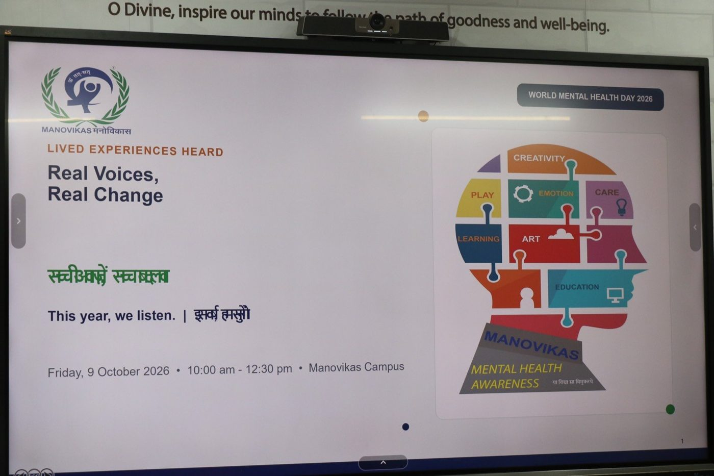  Opening: the theme on screen | The hall: students, parents and D.Ed. trainees
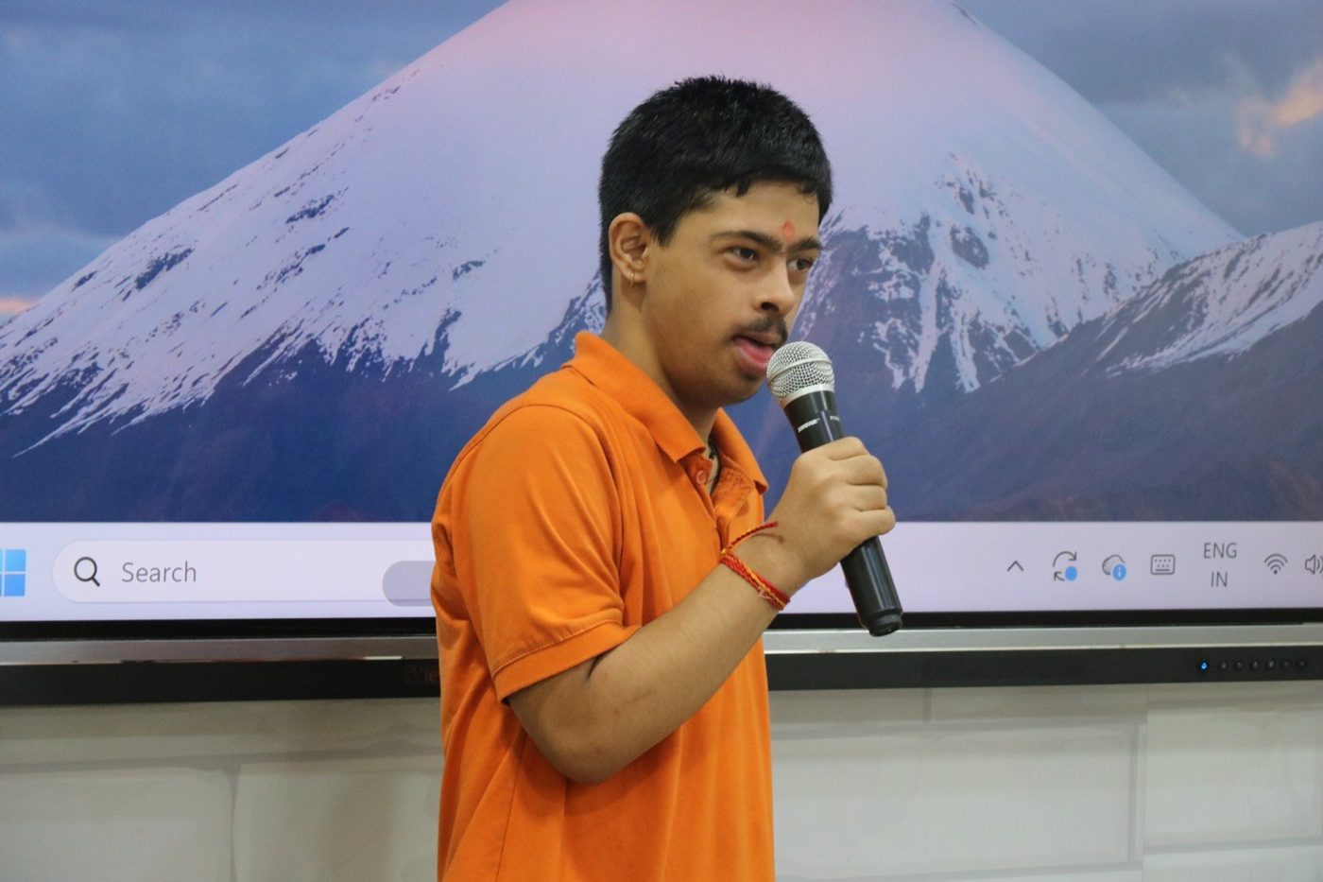  Student Voices: a student shares his story | 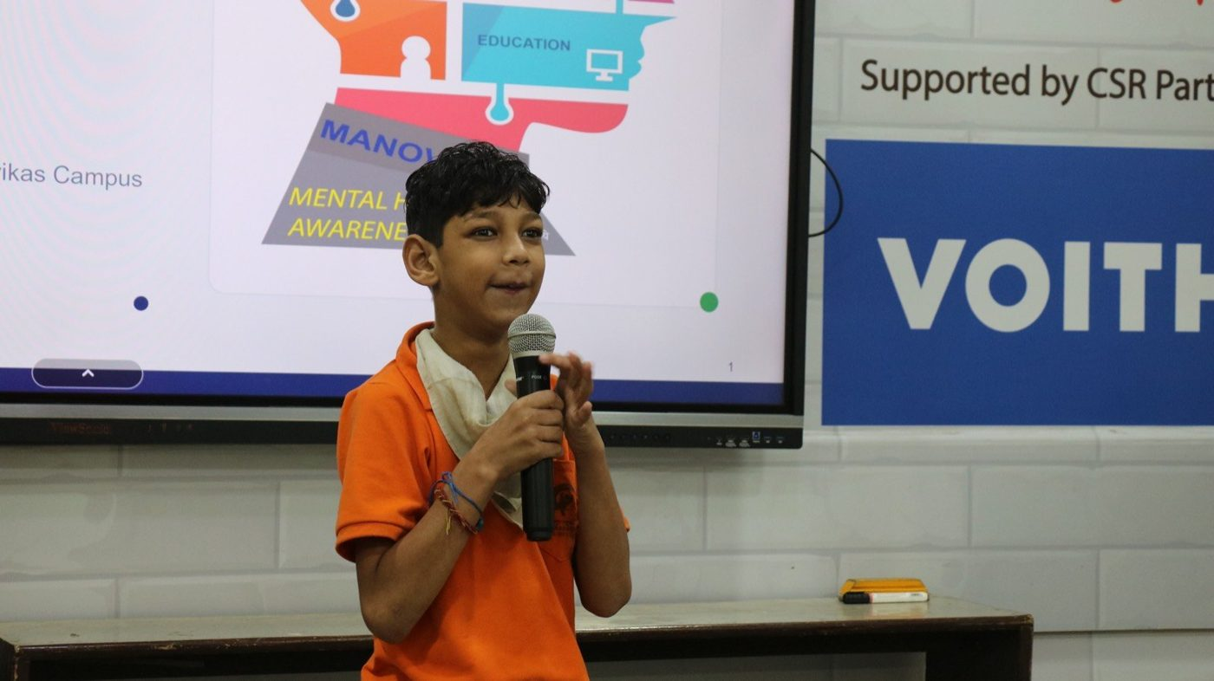  A young student speaks to the group
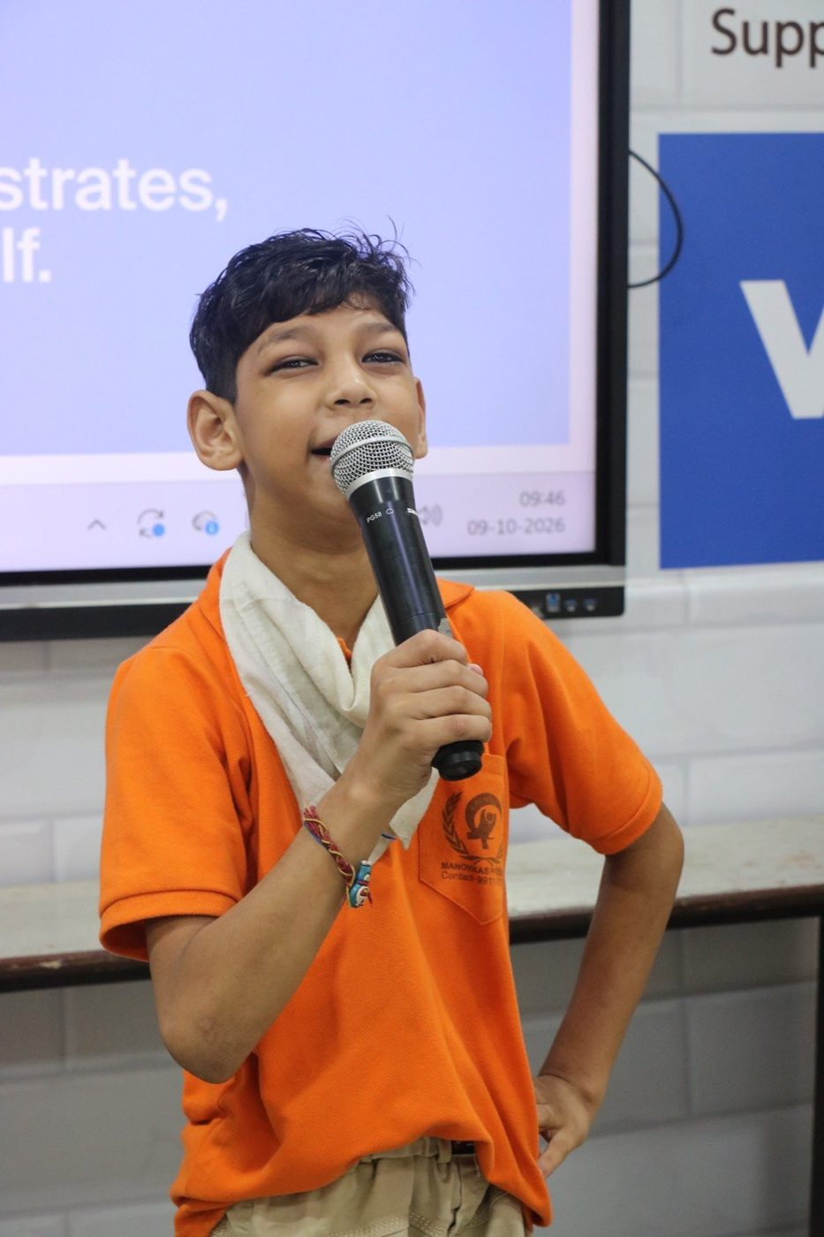  Speaking with confidence | 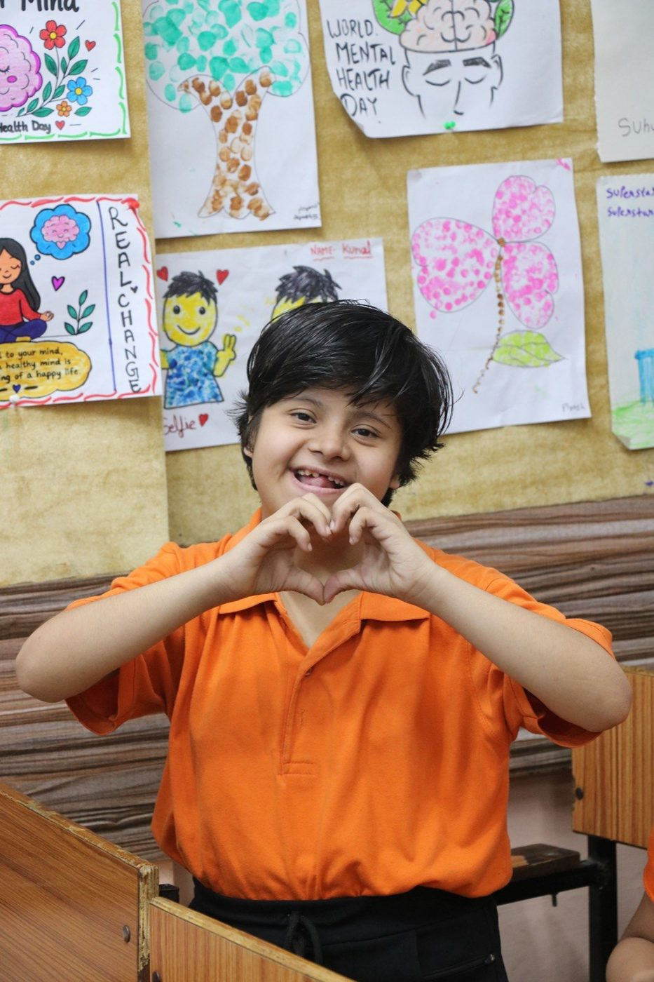  A message of care
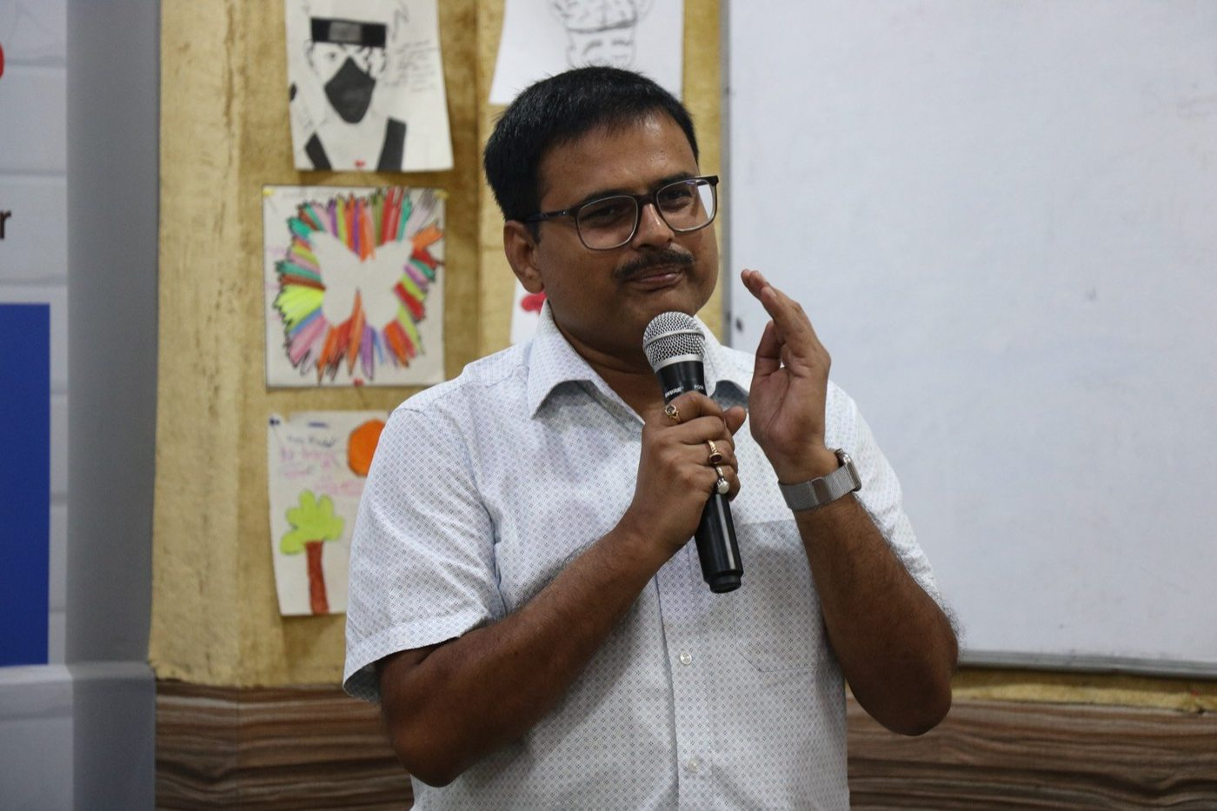  The facilitator guides the listening session | 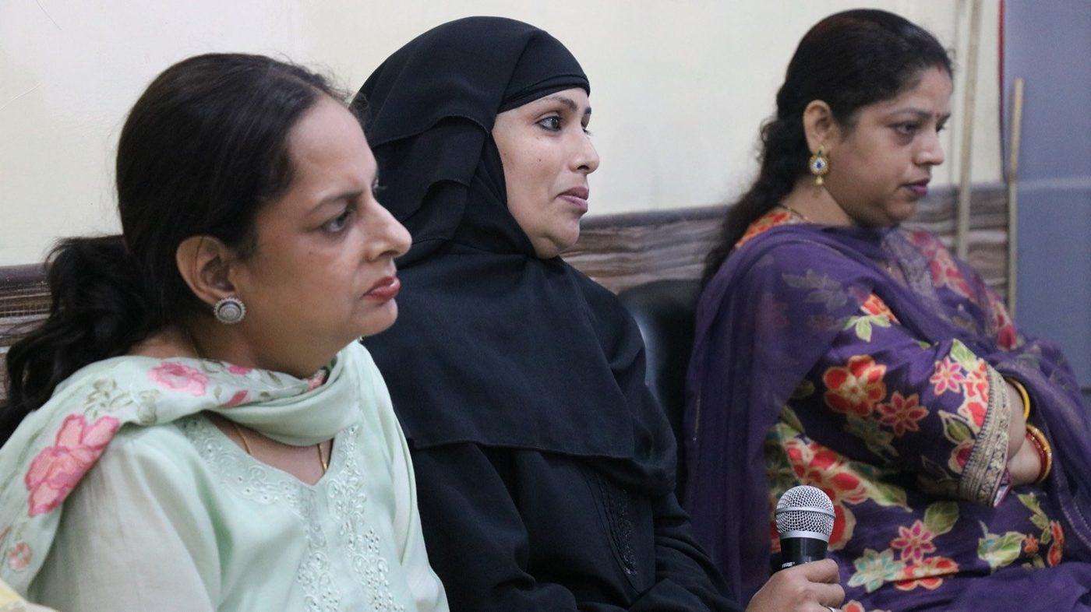  Parent Circle: mothers share their experience
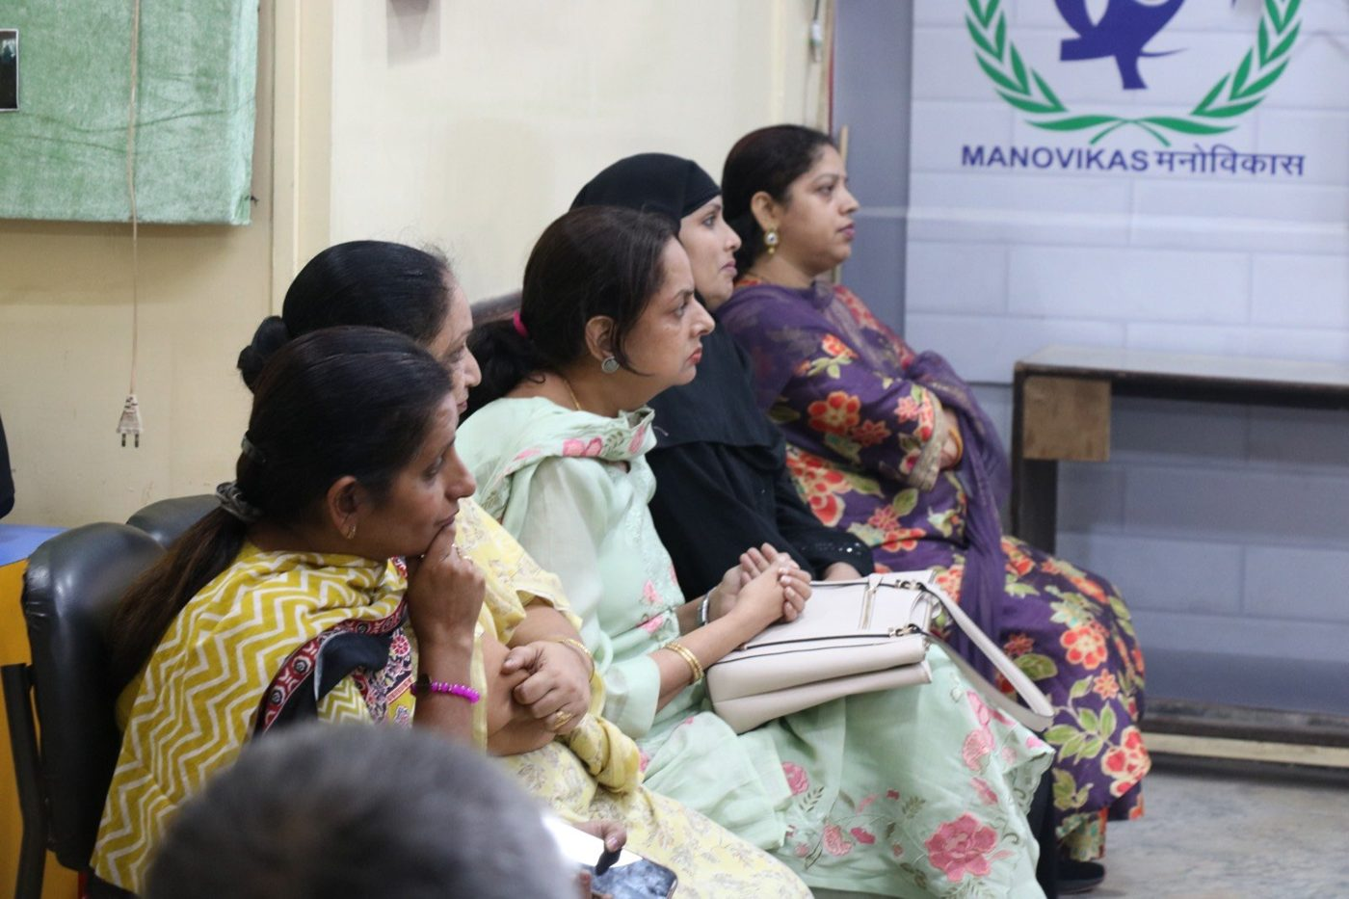  Parents and guests listen | 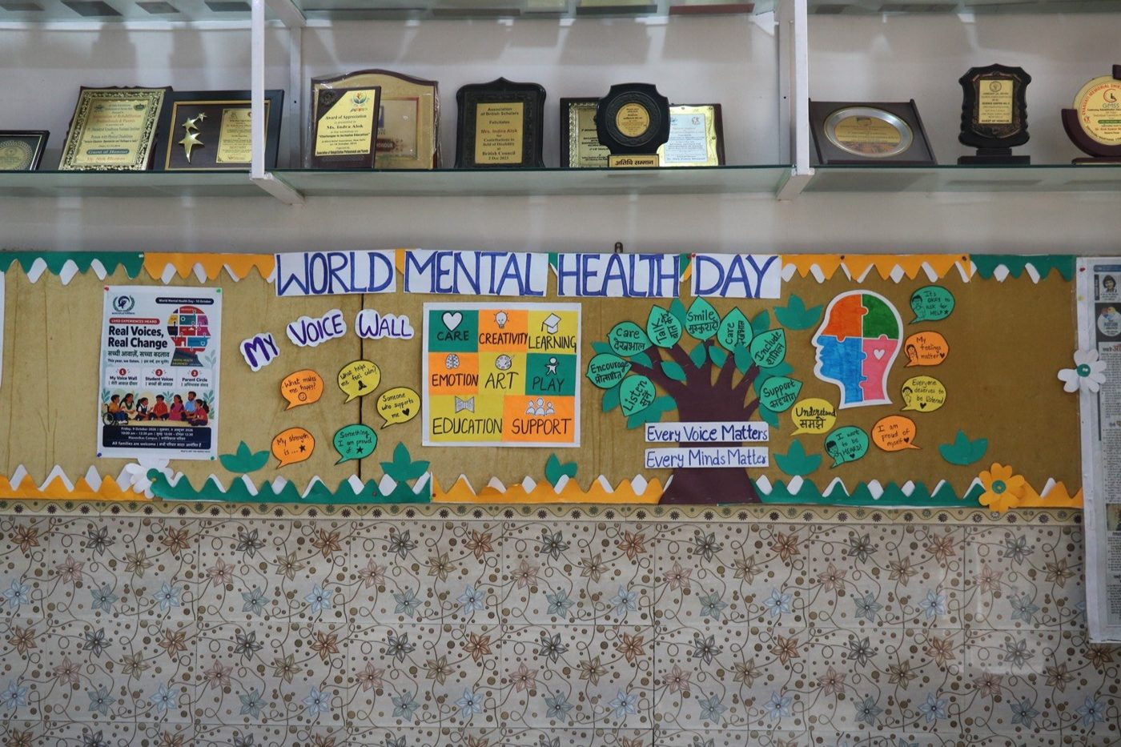  The My Voice Wall
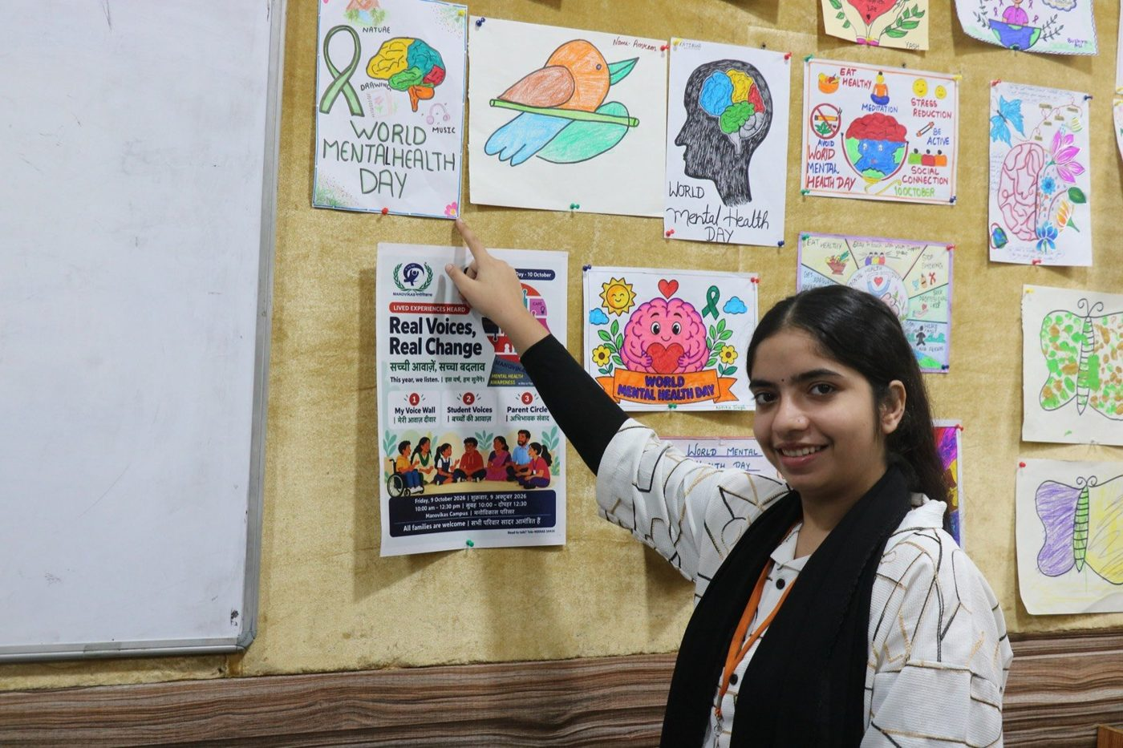  D.Ed. trainees with their poster gallery | 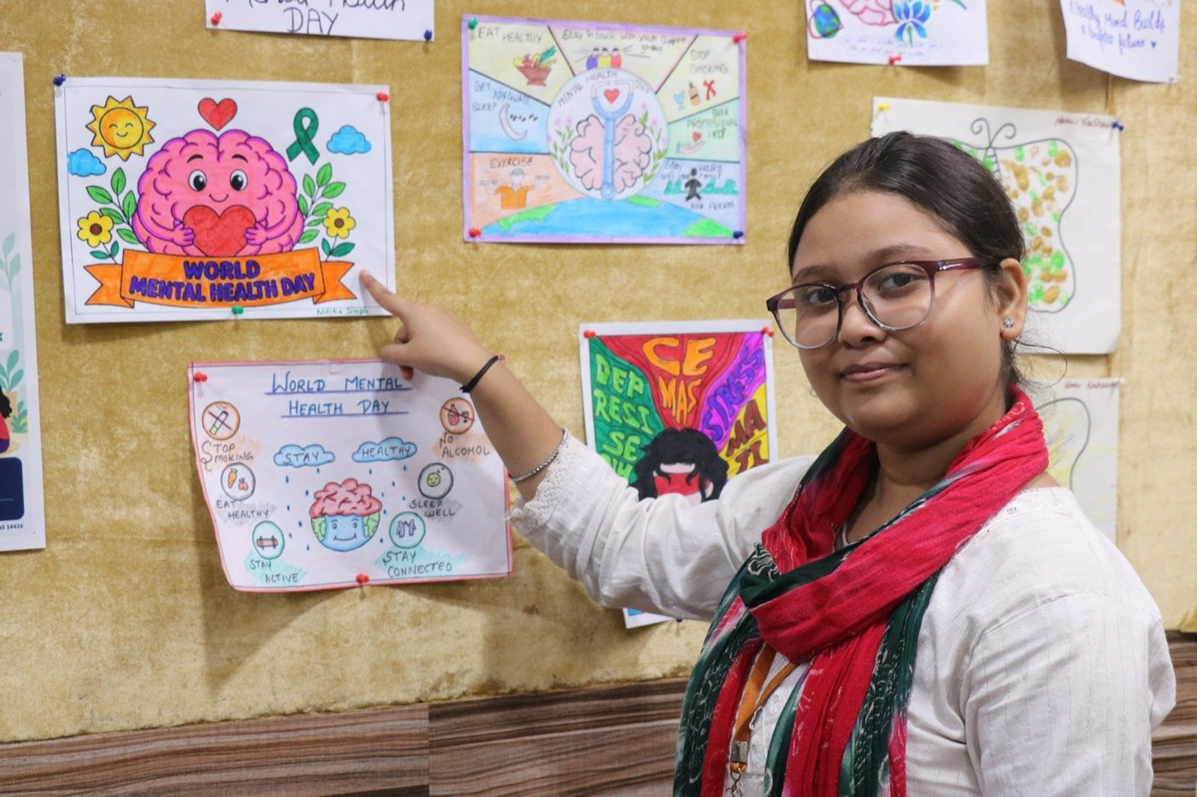  Mental health awareness posters by D.Ed. trainees

9. Links and resources
Resource | Link
Download this report (PDF) | https://site.manovikasfamily.org/assets/wmhd2026/Manovikas_WMHD2026_Event_Report.pdf
Read this report online (Google Doc) | Manovikas WMHD 2026 Event Report
Event page and recap | https://site.manovikasfamily.org/wmhd-2026
Impact dashboard (live figures) | https://site.manovikasfamily.org/impact
Open data feed (KPIs, machine-readable) | https://site.manovikasfamily.org/api/kpis.php
All Manovikas events | https://site.manovikasfamily.org/events
Instagram: Manovikas Charitable Society | https://www.instagram.com/manovikascharitable/
Facebook: Manovikas Family | https://www.facebook.com/manovikasfamilynetwork/
Photo album (full set) | https://photos.app.goo.gl/ehcVAjXpaWc1geyE7
Session notes (source for section 4) | Event Report: World Mental Health Day Program (Google Doc)
Manovikas Institute of Higher Education | https://mihe.ac.in
Mental health helpline | Tele-MANAS 14416 (free, 24 hours, Government of India)

10. Data, consent and verification
- Attendance figures are approximate head counts by group; no register was kept on the day.
- No personal data is published. Figures on the website are aggregated.
- Participant names and photographs are included for the official record. Before using this report in a public publication, confirm name and photo consent for each student shown, or remove names and use photos of the wall, posters and adults only.
- Communication figures are taken from the WhatsApp Business Manager, the newsletter system and the website records.
Sign-off
Role | Name | Signature | Date
Prepared by
Reviewed by
Approved by | Dr. Alok Kumar Bhuwan, Founder & Managing Secretary

